AWS Task-4
Launch an EC2 instance (Linux and Windows) along with a web server. Then, create an EBS volume of 5 GB, attach it to an EC2 machine (Linux and Windows), and take a snapshot. Finally, create an EBS volume using the taken snapshot.

Linux based EC2 instance launched.
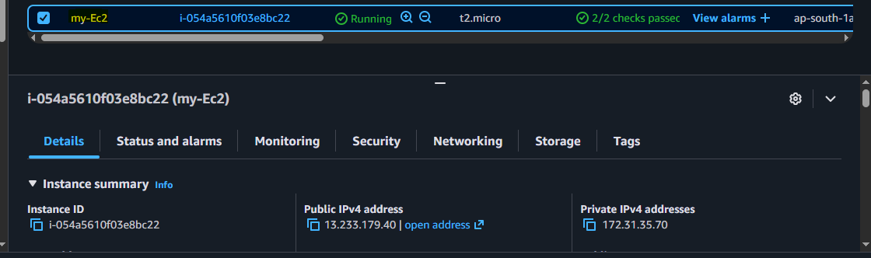
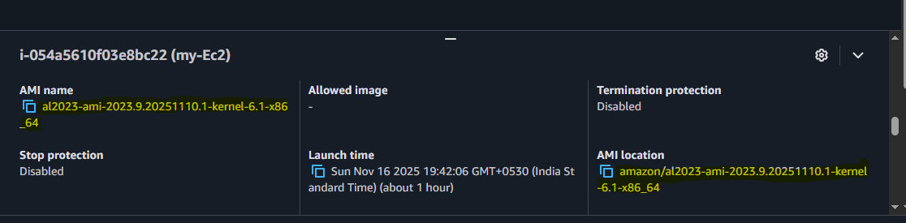
Created the EBS volume of 5 GB
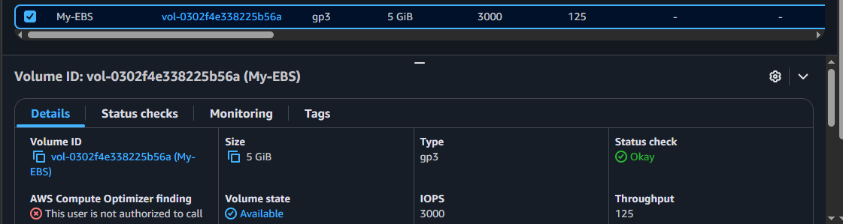
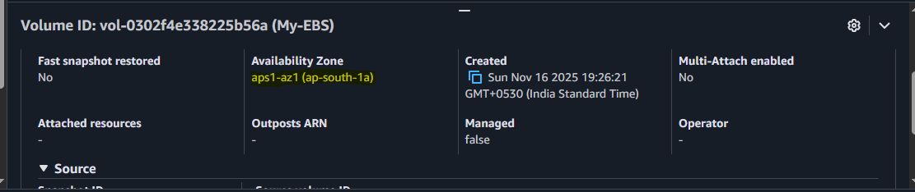

Attached the EBS volume to the EC2 instance.
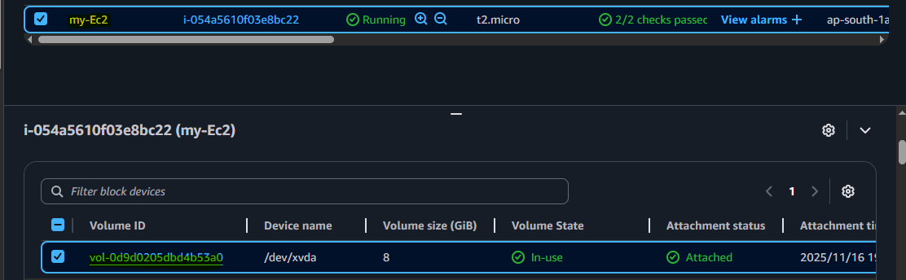
Snapshot created for the EBS volumes.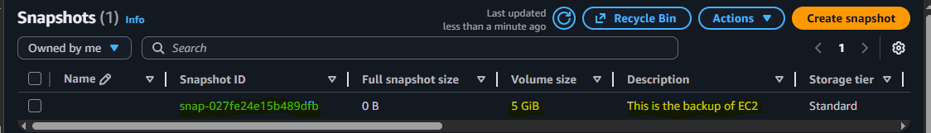
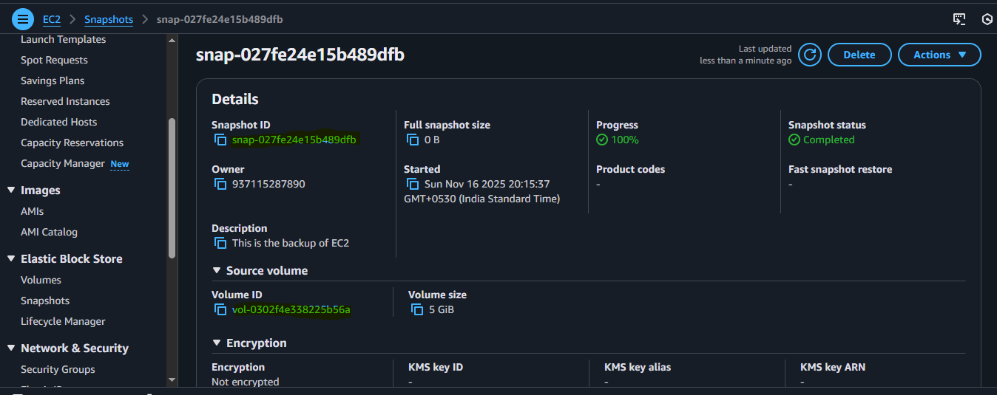
Created the EBS volume using the taken snapshot.
